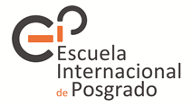
Granada, 28 de julio de 2026

D./Dª.«Nombre» «Apellidos»
«Dirección»
«Ciudad»
«País»

With regard to your request for pre-admission to undertake partial studies at PhD level (exchange or sandwich stay) at this university during the academic year ……, to seek funding via public calls for scholarship applications, we have pleasure in issuing this letter of APPROVAL.

This admission will be valid only in the case of obtaining a scholarship through an international public call for funding applications.

Please also note that in order to secure your place on your programme of choice it is a mandatory requirement to be enrolled at PhD level at your university of origin.

For more detailed information about our International School for Postgraduate Studies and PhD programmes, please visit the following link:

http://escuelaposgrado.ugr.es/doctorado

Yours sincerely,

Signed ...............................................

Coordinator of the PhD Programme

